**Lab Numpy Mathematical Operaations(Day-20)**

**1. Calculate the total revenue generated by two product categories in a store**

**Input:**

**category1_revenue = np.array([500, 600, 700, 550])**

**category2_revenue = np.array([450, 700, 800, 600])**

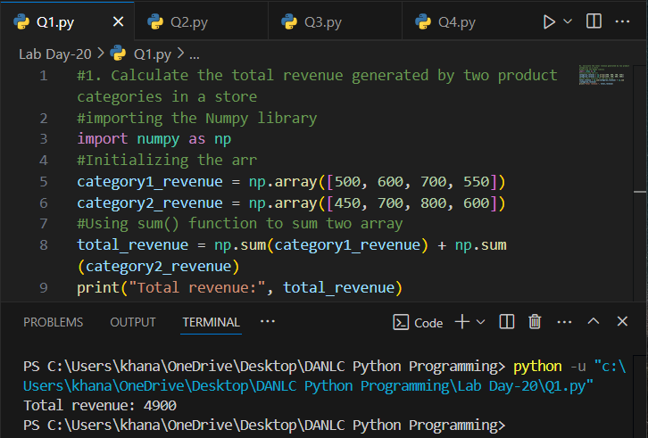

**2. Calculate the profit made by a company**

**Input:**

**revenue = np.array([10000, 12000, 11000, 10500])**

**expenses = np.array([4000, 5000, 4500, 4800])**

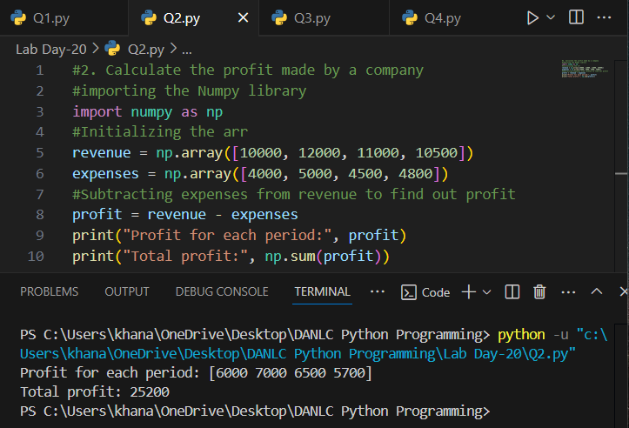

**3. Determine which products in a store are out of stock (quantity is 0).**

**Input:**

**inventory = np.array([10, 0, 5, 0, 20, 0])**

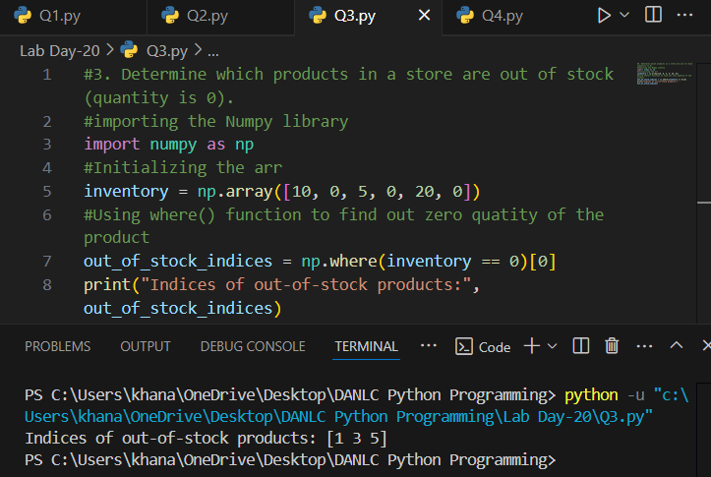

**4.Calculate the total cost of items in a shopping cart, considering the quantity and price**

**per item.**

**Input:**

**quantity = np.array([2, 3, 4, 1])**

**price_per_item = np.array([10.0, 5.0, 8.0, 12.0])**

